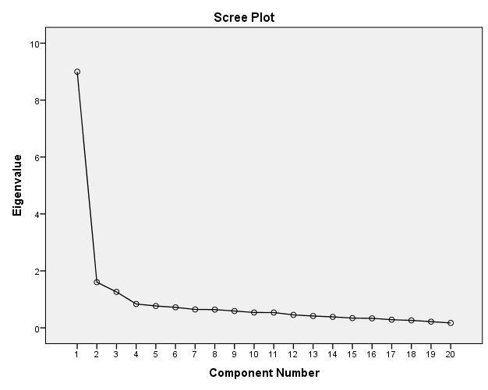
Figure 1. Scree Plot of the Burnout Scale Items
Table 1
Factor loadings of the initial 20-item Burnout Scale items (N = 443)
Item |  | F1 | F2 | F3
BS_1 | I feel weak while at work. | -.02 | .75 | .05
BS_2 | I do not have enough energy to carry out my daily tasks. | .11 | .71 | .08
BS_3 | I do not have the energy to go to work in the morning. | .08 | .73 | .04
BS_4 | I feel exhausted at the end of a working day. | .04 | .72 | -.04
BS_5 | I feel emotionally exhausted at work. | .10 | .76 | -.03
BS_6 | My work makes me feel weary. | .13 | .43 | .35
BS_7 | I do not feel like building relationships with my co-workers. | .00 | -.04 | .84
BS_8 | I lack the energy to build relationships with people at work. | .07 | .05 | .73
BS_9 | I feel I am less connected to my work. | -.03 | .13 | .69
BS_10 | I feel frustrated at work. | -.13 | .37 | .56
BS_11 | I am unable to imagine the feelings of my co-workers. | .16 | .08 | .54
BS_12 | I am not emotionally affected by how other people at work feel. | -.03 | -.02 | .66
BS_13 | I am not excited about my job. | .23 | -.23 | .62
BS_14 | I do not think clearly while at work. | .65 | .22 | .08
BS_15 | I cannot concentrate while at work. | .70 | .19 | .06
BS_16 | I struggle to process problems quickly. | .67 | .07 | .07
BS_17 | The thought of the work I have to do make me tired. | .50 | .34 | .12
BS_18 | I find it difficult to learn new things on my job. | .81 | -.13 | .07
BS_19 | I find it difficult to think about complex things while at work. | .89 | -.08 | -.05
BS_20 | I am not focused while working. | .65 | .20 | -.02
* Items in bold indicate items that loaded on more than one factor.
Table 2
Pattern matrix of the 17-item BS for the total sample.
Factor | Item nr | Item | F | h²
F1 | BS_14 | I do not think clearly while at work. | .66 | .69
 | BS_15 | I cannot concentrate while at work. | .72 | .71
 | BS_16 | I struggle to process problems quickly. | .69 | .57
 | BS_18 | I find it difficult to learn new things on my job. | .78 | .63
 | BS_19 | I find it difficult to think about complex things while at work. | .89 | .70
 | BS_20 | I am not focused while working. | .67 | .57
F2 | BS_1 | I feel weak while at work. | .77 | .61
 | BS_2 | I do not have enough energy to carry out my daily tasks. | .71 | .65
 | BS_3 | I do not have the energy to go to work in the morning. | .75 | .64
 | BS_4 | I feel exhausted at the end of a working day. | .72 | .52
 | BS_5 | I feel emotionally exhausted at work. | .77 | .65
F3 | BS_7 | I do not feel like building relationships with my co-workers. | .79 | .65
 | BS_8 | I lack the energy to build relationships with people at work. | .75 | .65
 | BS_9 | I feel I am less connected to my work. | .66 | .53
 | BS_11 | I am unable to imagine the feelings of my co-workers. | .52 | .46
 | BS_12 | I am not emotionally affected by how other people at work feel. | .72 | .46
 | BS_13 | I am not excited about my job. | .66 | .50

Table 3
Descriptive statistics, reliability and Pearson correlation coefficient of the factors
Factor | Mean | SD | Skewness | Kurtosis | α | 1 | 2
1. Cognitive Weariness | 12.40 | 5.56 | 0.79 | -0.03 | .88 | 1
2. Fatigue | 13.54 | 5.04 | 0.27 | -0.35 | .85 | .56* | 1
3. Emotional Exhaustion/ Withdrawal | 14.02 | 5.54 | 0.57 | -0.35 | .82 | .63* | .49*
* Correlation is significant at the .01 level (2-tailed).

