INTRODUCTORY PAGE
Dear corresponding author,
Contact person for all copy-editing enquiries: Margo Martens (submissions@ojvr.org)
I would like to take this opportunity to inform you that the copy-edited (i.e. language edited) version of your manuscript, has been released for your perusal. It follows after this introductory page.
I kindly request that you make the necessary arrangements to ensure that you have ample time to review the manuscript. It will be to your advantage if we receive your manuscript within two working days. It is important to note that your article has been accepted for publication after being subjected to a blind peer review process, it should be understood that we do not allow large new portions of text (ideas or concepts) to be introduced to the accepted manuscript at this stage. If large portions of text are inserted into the article we will transfer it back to the review-stage for another round of peer review, which will cause a delay and added expenses in the publication of your article.
To avoid costly publication delays we ask that you carefully scrutinise the changes that have been suggested by the professional language editor. Please ensure that you have enabled the ‘track change’ function in your version of Microsoft Word prior to addressing all points of concern by:
- answering all questions posted by the copy-editor
- providing omitted information both in terms of the content of the manuscript and the references
- making your changes in track changes; again, please leave the existing comments – this will assist our language editor with the preparation of your article for layout.

Incomplete manuscripts will be sent back to the author for rectification.
Understanding your language controlled article:
We use highlighting colours to identify first, second and third level headings in the text. We kindly request that you do not remove these highlights.
- Pink: First level headings
- Light-blue: Second level headings
- Green: Third level headings
- Yellow: Headings of images (Tables/Figures/Diagrams etc.)
- Grey: Footer text of any images (Tables/Figures/Diagrams etc.)
- Red: Any foreign text and mathematical symbol

‘Track Changes’ is a way for Microsoft Word to keep track of the changes that our copy-editors make to a manuscript.
- Please do not choose to accept track changes.
- Please do not reject suggested edits; rather make a separate comment stating your reason for rejection.
For more information on how ‘Track Changes’ works, please consult the Help function within your version of Microsoft Word.
‘Comments’ is a way for the copy-editor to make a note at a specific point in the manuscript.
- Please do not delete the comment, either add your own comment in response or add your feedback within the posted comment.
For more information on how ‘Comments’ works, please consult the Help function within your version of Microsoft Word.
Completed your review of the copy-edited manuscript?
It is time to upload your completed review of the manuscript on the online journal website. Please follow the steps:
- Log into the journal website with your unique username and password.
- Click on ‘Author’ under your User Home.
- Click on the status link next to your active submission in the ‘Active Submissions’ table.
- At your articles Editing page, under Copyediting Step 2 please select browse and select your review of the copy-edited manuscript from where you saved in on your computer. Proceed to select Upload.

- A file will be under Step 2 of the copy-editing process; this means you have successfully uploaded a file. Ensure that this is the correct file by downloading it and checking that it is in order.
- To complete the process you will need to inform the copyeditor that you have completed the review of the document. Please click on the envelope icon under complete (circled) and send the email to the copyeditor.
- Congratulations! you have successfully reviewed your language edited document.

Thank you for your contribution to this journal – we are looking forward to publishing your work.
If at any time you need assistance, please do not hesitate to contact me.
Ms Margo Martens
Tel: 086 1000 381

TABLE OF CONTENTS PAGE
Section:
Original Research

Title:
Epidemiological perspectives of ticks and tick-borne diseases in South Sudan; Cross-sectional survey results

Authors:

Affiliations:

Correspondence to:

Email:

Postal address:
PO Box 9152, Dar es Salaam, Tanzania

Keywords:
Endemic stability, Infection and Treatment Method (ITM), Muguga cocktail

Dates:
Received: 09 Jan. 2012
Accepted: 11 May 2012
Published: [to be confirmed]

How to cite this article:
[to be confirmed]

Abstract
A cross-sectional study was conducted between September and October 2010 in five States of South Sudan that were selected based on perceived risk of tick-borne diseases. The purpose was to investigate epidemiological parameters of tick-borne diseases in South Sudan and their uses in future control strategies. A total of 805 calves were assessed by clinical, microscopic and serological examination and tick counts. The indirect ELISA was used to detect anti-bodies to Theileria parva, Theileria mutans, Anaplasma marginale and Babesian bigemina. Sero-conversion risks for T. parva and T. mutans were 27.3% and 31.3% respectively, while the risk was 57.6% and 52.8% for A. marginale and B. bigemina, respectively. Major tick species identified include Rhipicephalus appendiculatus, Rhipicephalus decoloratus, Rhipicephalus microplus, Amblyomma variegatum, and Rhipicephalus evertsi. There was great variation (P ≤ 0.001) in the number of all these ticks, both between herds in a State and between calves in an individual herd. The low and intermediate sero-conversion risks observed in the study states suggests that immunisation against ECF is justified. Fortunately, three major genotypes identified by applying PCR-RFLP analysis on the p104 to the blood samples and T. parva Muguga, matched very well with T. parva Kiambu 5 and T. parva Muguga; therefore the Muguga cocktail can be used for immunization of cattle in South Sudan. However, prospective studies are required to develop optimal control measures for tick-borne diseases under different ecological and husbandry practices in South Sudan.

Introduction
Infection with Theileria parva causes the disease East Coast fever (ECF), also known as bovine theileriosis. The disease is endemic from the Democratic Republic of Congo to Tanzania, from South Sudan to South Africa; with a heterogeneous distribution and prevalence strongly related to its vector dynamics, host susceptibility, grazing system and tick control practices (Rubaire-Akiiki et al. 2006; Kivaria 2007; Marufu et al. 2010). In all affected areas, ECF has a considerable epidemiological and economic significance, in Tanzania; the disease is the main cause of reported cattle deaths and was estimated to account for 68% of the 364 million USD annual total losses due to tick-borne diseases (Kivaria 2006). In unvaccinated zebu calves raised by pastoralists, ECF is responsible for annual mortality risk of 40% – 80% (Kivaria 2006). The first outbreak of bovine theileriosis in Sudan was reported in 1950 (Hoogstraal 1956). After the 1950 outbreak the disease was not reported again until 198. Since then many outbreaks of ECF have been reported in Southern Sudan (Julla, Tingwa & Kwajok 1989; Julla 1993). In 1983, an outbreak was reported in Palotaka, Nimule and Juba Township with calf mortalities estimated at 80% – 100% (Julla 1985).

Unpublished archives indicate that the disease has previously been restricted to the Equatorial region of South Sudan, probably due to its proximity to ECF infected zones in Kenya, Uganda, and North East Congo; coupled with the suitable climatic conditions for the survival of the vector. During the two decades civil war in South Sudan, pastoralists from Jonglei State were displaced , and moved southward with their cattle to ECF infected areas in Central Equatoria State. The gradual introduction of these naïve animals into the infected zone generated some degree of immunity against the disease and the animals were able to survive the tick and parasite challenge. After the Comprehensive Peace Agreement (CPA) in 2005; Dinka Bor of Jonglei State started moving northward with huge numbers of livestock. In June 2008, the first outbreak of ECF was reported in an area called Lek Yek in Bor town, and thereafter, a cycle of outbreaks followed and continued through 2009 and 2010, affecting animal production and health as well as the food security of many households whose livelihoods are mainly dependent on livestock.
Results of several tick-borne diseases (TBD) studies in smallholder dairy and pastoral livestock farming systems in Eastern Africa indicated that TBDs’ sero-prevalence risk differ across agro-ecological zones and grazing systems (Bazarusanga et al. 2007; Maloo et al. 2001; Rubaire-Akiiki et al. 2004; Swai et al. 2005). The impetus to carry out this cross-sectional study was borne out of the desire to characterize the epidemiological parameters (sero-conversion risk, morbidity and mortality risks) and document the dynamics of tick infestation of cattle and the infection patterns of bovine theileriosis, babesiosis and anaplasmosis as these are very important factors to consider when planning production system-specific control strategies of TBD. In this paper we use these factors to characterize the epidemiological states of ECF and other tick-borne diseases, namely Anaplasmosis and Babesiosis in Central Equatoria (CE), Eastern Equatoria (EE), Jonglei (JNG), Lakes (LKS) and Western Equatoria (WE) States of South Sudan. In addition, molecular characterization of T. parva isolates was done, this information was then combined to assess current and potential TBD status in each State and implications for future control strategies.
Materials and methods
Sample size
This cross-sectional study was designed and implemented between September and October 2010. One of a methodological challenge faced during the execution of this survey was lack of information on husbandry practices and estimated herd level prevalence of tick-borne diseases. Based on results by Deem et al. (1993) who suggested that a sample size of 10–20 pastoral herds that contained an average of 10 calves per herd would be adequate across a range of epidemiological states, with sample sizes at the top of the range required in epidemiologically unstable areas. It was therefore decided to randomly select 20 cattle camps from each state and 6 calves from each selected camp. A three stage sampling was employed, Payams/divisions were purposefully selected first based on the perceived risk of tick-borne disease, then cattle camps/boma were randomly selected, and then animals were randomly selected from each cattle camp. The resulting final sample size therefore depended on the number of camps and calves sampled from each State and cattle camps, respectively. Figure 1 depicts the geographical location of the 5 States, Counties and the cattle camps investigated during the study period.

The target age group was calves of age 4–18 months. Aging was done based on the herdsman derived information and on the absence of permanent incisors. All herdsmen were questioned on the occurrence of tick-borne diseases, herd size, calf mortality, descriptions of clinical signs observed in calves that had died, acaricide usage, treatment, distance travelled to water and grazing, and the general descriptions of tick problems present in each herd.

Clinical and laboratory investigation
Each animal was subjected to clinical examination, rectal temperature, a temperature of ≥ 39.5 °C in adult (> 12 months) and ≥ 40 °C in calves (≤ 12 months) were considered as a febrile reaction. Palpation of the pre-scapula lymph nodes, the sizes were scored as + (normal); ++ (slightly enlarged) and +++ (grossly enlarged). In this study, lymph node enlargement of (+) were defined as having originated from animals free of theileriosis while palpation results of ≥ ++ were classified as evidence of theileriosis. Blood smears and lymph node biopsies were taken to demonstrate the presence of the causing organism. Smears were Giemsa stained and microscopically examined under 40x and 100x oil immersion objectives.

Tick counts and tick infection proportions
Tick infestation was estimated by counting the number of adult ticks (males, females, engorged and non-engorged) on the body of each calf examined. Because ticks are not randomly distributed on the animal body but rather restricted to a few predilection sites we preferred to count all the ticks on one side of the animal body instead of making counts per square meter. The ticks on one side of the body of each calf were counted and categorized into species; identification was done visually during the tick counts, based on the guidelines described by Walker et al. (2003).
Adult Rhipicephalus appendiculatus that were partially engorged and thus potentially with developing sporoblast stages of T. parva were dissected to remove the salivary glands for examination of infection with T. parva, as described by Buscher and Otim (1986). Tick infections were determined through direct microscopy after staining the tick salivary glands with Schiff's (Fuelgen's) reagent to identify infected acini. The intensity of infection was subsequently estimated by counting the number of infected acini.

Serological tests
Blood was collected from each calf in one 10-mL plain vacutainer tubes (Becton Dickinson Vacutainer Systems, UK) by jugular venipuncture. Labeling of tubes was carried out and verified before drawing the blood from the calves. After collection, blood samples were stored in a car refrigerator until when sera could be separated (usually within 24 hours). The sera were separated by centrifugation at 3000 X g for 20 minutes and divided into aliquots and stored in freezers (-20 °C) in the laboratory.

ELISAs were used to detect antibodies to T. parva, Theileria mutans, Anaplasma marginale and Babesian bigemina. Polymorphic immune-dominant molecule (PIM) recombinant antigen was as described by Katende et al. (1998), for the detection of T. parva antibodies. Tests for antibodies to T. mutans and B. bigemina have been described by Katende et al. (1990, 1998). Each ELISA test plate included predetermined positive and negative control sera. Optical density (OD) readings from the reference highly positive control sera were used to compute the percent positivity (PP) for the test sera (Wright et al. 1993). Percent positivity (PP) for test serum was expressed as the percent of the test serum OD (at optimum dilution of 1:200) divided by the mean OD reading derived from the strong positive control serum on the linear curve (from a curve of OD against the reciprocal of serial dilutions) (Katende et al. 1998; Wright et al. 1993). For T. parva and T. mutans, a sample was considered positive if the PP value was 20 or above, while the cut-off point was 15 for A. marginale and B. bigemina. The risk of exposure of animals to T. parva was estimated by the sero-conversion risk. The sero-conversion risk was computed as; the number of animals sero-converted or the total number of animals tested. Tick identification, microscopic and serological work were conducted at the veterinary investigation centre in Arusha, Tanzania.

Characterisation of epidemiological states of tick-borne diseases
The epidemiological state of tick-borne diseases in an area can be considered as either endemically stable or unstable. For babesiosis and anaplasmosis, antibody prevalence has been used as an indicator of the existence of endemic stability, and thus the biological evidence of the need for vaccination or for no intervention. (De Vos 1992; Mahoney 1977). In broad terms, there is a strong correlation between high antibody prevalence to these infections and endemic stability, and low antibody prevalence and endemic instability. This phenomenon also exists with T. parva, but it is by no means absolute, and complicated by various factors. Endemic stability is assessed based on a combination of indicators (Norval, Perry & Young 1992), including; (1) antibody prevalence, (2) disease incidence, (3) case-fatality proportion, and (4) age group affected (Norval et al. 1992; Perry & Young 1995), tick infection proportions are also considered helpful (Perry et al. 1992). According to Norval et al. (1992), an endemically stable state is characterized by high antibody prevalence, low disease incidence and case-fatality proportion and a rapid acquisition of infection in young calves. An endemically unstable state is characterised by the opposite: lower antibody prevalence, high disease incidence and case-fatality proportion and primary infections that occur in all age groups. These criteria were used to characterise the endemic stability of the five States investigated.

Molecular characterisation of Theileria parva isolates from South Sudan
Lymph node biopsy and blood samples collected from cattle were used as the source of deoxyribonucleic acid (DNA) for polymerase chain reaction (PCR) analysis. Genomic DNA was extracted from blood samples received from Southern Sudan. DNA was also extracted from stabilate of T. parva Muguga (Muguga, Kiambu 5, Serengeti transformed) obtained from Ministry of Livestock and Fisheries Development, Dar es Salaam and used as control DNA for the processes in the characterization. The DNA extraction and PCR assays were conducted as described Bishop.

Ethical considerations

Results
A total of 822 calves from the 5 states, 16 counties, 29 Payams and 34 cattle camps were investigated, 805 calves had complete observations, while 17 calves did not have all the information, and were therefore omitted from further analyses. Of the 805 calves investigated, 50.4% were females, while 49.6% were male calves; the mean age for female calves was 9.34 months and for males was 8.98 months. The mean age of the studied calves was 9.16 months, while minimum and maximum ages were 0.75 and 24 months, respectively.

Temperature, Lymph node scores, biopsies and blood smears
The average temperature was 38.0 °C ± 0.16_{SE}, the median was 38.20 °C and the mode was 41 °C, there was no significant (X² = 6.342) statistical difference in the distribution of temperature recordings among the States.

A total of 805 pre-scapula lymph nodes were examined, 45% were – positive, with reactions of ++ or higher; 55% of the 805 pre-scapula lymph nodes showed a negative reaction of +. Palpation results of ++ and +++, accounted for 34.6% and 10.4% of the palpated lymph nodes. Of the 362 grossly enlarged pre-scapula lymph nodes, 3% (11) were positive for schizonts; the remaining smears were negative. T. parva piroplasms were detected in 32 corresponding blood smears, 6 out of the 32 T. parva positive blood smears were a mixed infection between T. parva and A. marginale.

Blood parasites were detected in 9% (72) of the 805 blood smears examined; the haemo-parasites detected include T. parva (26), A. marginale (38), T. parva and A. marginale (6), B. bigemina and A. marginale (1), and trypanosome species (1). Due to the small number of haemo-parasites detected, no statistical comparisons were made for the distribution of these parasites by States; the distribution of these haemo-parasites by States is summarized in Table 1.

<Insert Table 1 here>

Theileria parva, Theileria mutans, Anaplasm marginale and Babesia bigemina antibody patterns
Serological results indicated that, 27.3% (220) of the 805 calves screened have sero-converted against T. parva, and 72.7% (585) were negative, while for T. mutans 31.3% (252) and 68.7% (553) of the 805 calves screened were sero-positive and negative, respectively. On the other hand, 57.6% (464) and 52.8% (425) of the 805 calves were sero-positive for A. marginale and B. bigemina antibodies, respectively. The mean antibody sero-prevalence with standard errors for T. parva, T. mutans, A. marginale and B. bigemina by States are shown in Figure 2. Central Equatoria State was significantly associated with higher sero-prevalence compared with other States.

Figure 3 (a–d) shows the relationship between the calf age and sero-prevalence, the Figure shows that majortiy of the calves are borne with very little (negative sign) maternal antibodies to the major tick-borne parasites studied, they however sero-convert by the age of three months, the age at which according to the herdsmen, is the time when calves go out for grazing. However, the acquired antibodies quickly decay with advancing age, insuch a way that majority of the calves have less than 15% sero-prevalence by 11 months of age.

Tick infestation patterns
The occurrence and distribution of ticks in the study States are shown in Table 2. The highest number of tick counts was made in the Eastern Equatoria and Central Equatoria States. The most prevalent ticks were R. appendiculatus and Amblyoma variegatum and these were observed in Eastern Equatoria and Central Equatoria States, respectively. Table 2 further shows that infestation by ticks (total ticks and individual species) significantly (P ≤ 0.001) varied with States, especially in Eastern Equatoria and Central Equatoria States; there was also great variation in the number of ticks between calves in an individual herd. No ticks were collected from the Western Equatorial State. Table 3 lists the numbers of R. appendiculatus dissected, the proportion infected with T. parva and the intensity of those infections. The prevalence of infections in dissected tick was in the range 25% – 28%.

Epidemiological states of Theileria parva, Theileria mutans, Anaplasma marginale, and Babesia bigemina infections
ELISA results for T. mutans and B. bigemina are summarised in Table 4, these results were used to classify the five states for endemic stability. Table 4 shows that all States are endemically unstable to T. mutans, but moderately stable to B. bigemina. No morbidity and mortality risk data for T. mutans and B. bigemina were available. The estimates of indicators used to classify the five States for endemic stability to ECF and anaplasmosis are listed in Table 5 and 6, respectively. All strata were judged to be endemically unstable; however, the degree of their instability varied. Our assessment of the relative stability of each State over the range of endemic stability/instability is indicated in Tables 5 and 6.

Molecular characterisation of Theileria parva
The profiles generated by applying PCR-RFLP analysis on the p104 to the samples and T. parva Muguga were obtained. Three major genotypes were identified. The first genotype appeared exactly similar to T. parva Muguga and T. parva Kiambu 5 at p104 locus with two bands at approximately 220bp and 280bp. The second genotype had a lower band at 150 bp and the higher similar to T. parva Muguga at 280bp. And the last genotype had a band similar to T. parva Muguga at 280bp and a higher at about 400bp. The results are summarized in Table 7.

Survey of herdsmen
Interviews with the herdsmen revealed that they were not willing to provide information regarding their animals. However, the following direct observations were made. The study States are suitable for many types of agricultural activities including livestock keeping. The lush pastures, huge trees and other types of vegetation, indicates abundant rainfall. This was confirmed through the consultative discussions with the State veterinarians and herdsmen who indicated only 3–4 months of the year are dry. This also means that many parts of the country are suitable habitat for the ticks-and their respective diseases. Nearly all the herds observed were zebu breeds and the animals were generally in a good health. Animals graze communally in designated areas and only separated in the evenings into different herds belonging to different families. Members of the same family keep their animals together at night for ease of guarding them. It was of great epidemiological interest to note that about 90% of the herdsmen met and even some of the livestock field personnel did not associate ECF with ticks. Instead, they viewed ticks as a major problem only due to their direct physical effects on the animals. This was considered a major instrumental factor in planning of future ticks and tick-borne diseases control interventions.

However, despite the general lack of information on TBD, there are some indications that livestock keepers are aware of the existence of ECF and other TBD (majority of herdsmen described clinical signs compatible with those of ECF in their calves), they have perfected traditional methods of treating the diseases. A standard method of treatment observed during the field investigation is the burning of lymph nodes with a hot iron and cauterizing them with caustic juice derived from a plant. Farmers reported that this treatment is effective when applied early in the course of the disease. However, it was difficult to substantiate whether the recovery is due to the treatment or due to an inborn resistance to the diseases by the calves. Indigenous cattle are known to develop resistance to the vector tick and to tick-borne diseases (Norval et al. 1992). The fact that the case fatality rate from ECF was reported to be so high (Table 5), puts into question herdsmen’s interpretation of the effectiveness of the treatment.

Currently control of tick-borne diseases is minimally limited to irregular use of acaricides (mainly to control tick infestation – herdsmen reportedly used acaricides when sufficient funds became available) and chemotherapy, the herdsmen also control ticks by the application of cattle urine mixed with ash. The main constraints to proper control were found to be lack of infrastructure (service providers, dipping facilities and drug outlets). There was also a general lack of information on livestock husbandry. For instance the failure of herdsmen to associate ticks with ECF. Generally there are very little infrastructure in South Sudan to support large scale livestock interventions. For example there are only two dip tanks (one in Central equatoria, and one in Western bahr Elghazal State) and about 8 (Central Equatoria - 2, Eastern Equatoria – 2, Unit – 2 and Warrap Sate – 2) functional checkpoints and one quarantine facility in Eastern Equatoria, in the country. Apart from the active network of community animal health workers there are very few skilled personnel, communication and input markets are also lacking. Majority of the herdsmen reported lack of inputs and extension services as constraints to livestock keeping.

Trustworthiness

Discussion
The objective of this study was to investigate epidemiological parameters that may influence the development of ticks and tick-borne disease control strategy for South Sudan. The study areas were purposefully selected based on the perceived ticks and tick-borne disease risk. In pastoral production systems calves and other young animals are usually left to graze near the homestead, hence they were considered to be resident and the survey findings are therefore a true picture of the existing ticks- and tick-borne disease situation in the given area. Results obtained by Deem et al. (1993) suggest that, when sero-prevalence results from cross-sectional studies are used to determine the epidemiological status of tick-borne diseases in a given production system it is important that sero-prevalence is assessed in homogenous systems if they are to be interpreted. Such homogenous systems should incorporate the same cattle type (in terms of their susceptibility), the appropriate age-group, sampled at the appropriate time of year and within appropriate strata of the ecological cline. However, this requirement is more important if herd sizes are very small, as in the zero-grazing smallholder herds; in this study larger pastoral herds were used, and given the communal grazing and husbandry practices whereby at one point in time almost the entire national herd congregate along the Nile River during the dry spell. From an epidemiological perspective, the study population was therefore assumed to be a single, homogenous, free mixing host population.

Although it was not possible to reliably establish ECF specific case fatality risk, consultative discussions with the state veterinarians and the producers in the study areas indicate that case fatality risk due to ECF to be as high as 80% – 100% depending on the time of the year. These estimates compared very well with the results of a recent unpublished socio-economic study in the same areas, but the estimates are very high compared to what would be expected in the east Africa region where calf mortality due to tick-borne diseases range between 30% – 50% to as low as 2% – 3%, (Norval et al. 1992) depending on the different tick control practices and the existing endemic situation. However, ECF specific case fatality risk ranging between 50% and 100% are not uncommon in the region. Cases of death are common especially in high susceptible exotic breeds, such as Bos taurus, and their crosses with indigenous breeds, but also the indigenous breeds are at risk particularly in endemically unstable or epidemic areas (Norval et al. 1992).

Figure 3, suggests that majority of the calves are borne with very little or no (the negative sign) maternal antibodies to the major tick-borne parasites studied, they however sero-convert by the age of three months, the age at which according to the questionnaire results, is the time when they go out for grazing. However, the acquired antibodies quickly decay with advancing age; in such a way that majority of the calves have less than 15% sero-prevalence by 11 months. This could be due to several reasons. Firstly, the majority of dams are sero-negative to the common tick-borne diseases. Secondly, low tick challenge and if the tick challenge is good, then it is likely that several factors such as the number, viability, and infectivity of sporozoites within the salivary glands, pathogen and T. parva strain differences, and duration of tick feeding could interplay to influence the ability of the R. appendiculatus to acquire T. parva and the transmission of T. parva from infected-ticks to cattle. In endemic areas the majority of infected ticks likely become infected by feeding on carrier and clinically affected cattle (Medley, Perry & Young 1993), but the findings recorded in Table 1 and the presence of schizonts in only 3.11% of the study population suggest that the subsequent instars would then likely inoculate relatively fewer parasites, reducing the overall tick infectivity level, this is probably corroborated by the recent findings by Ogden et al. (2003) that the level of parasitaemia could affect the rate of acquisition of T. parva by ticks and the subsequent cattle challenge. However, it is worth noting that, in a given cattle production system the level of infection challenge will depend on classical risk factors such as climatic suitability for ticks, grazing practices and range (and thus mixing with other potentially infected cattle), tick control practices and host susceptibility. Thirdly, herdsmen in the study areas use cattle urine mixed with ash (the ammonia in urine suffocates the ticks, while ash is used as a binding material) to remove ticks from animals this practice interrupt tick challenge and may also contribute to the observations recorded in Figure 3. Fourthly, the relatively high risk levels particularly of anaplasmosis could result into early and high calf mortality which could also influence the resulting sero-prevalence patterns in the population, as calves do not live long to develop immunity.

The observed high level of tick infection depicted in Table 3 is probably owing to the fulminating theileriosis, and indeed the ticks with high infection prevalence in Jonglei state came from a cattle camp that reportedly had a recent outbreak of ECF just before the survey.

The high prevalence of tick infection is far above the recorded levels of 2.6% and 2.3% – 14.2% in more endemic areas of Tanzania and Kenya (Ogden et al. 2003; Oura et al. 2004).

Variations in sero-prevalence in the study sates suggest that tick-borne diseases exist in different epidemiological states, so morbidity and mortality will likely fluctuate from season to season and from herd to herd. This study, as in other previous studies in the East African region (Gitau et al. 1997; Rubaire-Akiiki et al. 2004, 2006), demonstrated the crucial influence of farm circumstances, grazing systems and agro-ecological zones on the variation in ticks and tick-borne diseases risk, both spatially and temporally. Thus, herdsmen and the veterinarians in South Sudan need to pay close attention to varying ECF challenge in making decisions on ECF and other TBD control.

The overall sero-prevalence of 27.30% and 31.30% for T. parva and T. mutans respectively, suggest that endemic instability exists in the study population and an outsized proportion of the population is likely to succumb to clinical theileriosis. On the other hand the overall sero-prevalence of 57.60% and 52.80% for A. marginale and B. bigemina is suggestive of a state of medium endemic stability. It has been suggested that high sero-conversion risks are associated with little or no clinical cases of tick-borne diseases (Norval et al. 1992). However, the high reports of clinical cases (Tables 5 and 6), indicate that this may not be the case, and clearly sero-prevalence alone is not a reliable indicator of endemic stability.

The results of this study have important implications for future ECF and other tick-borne disease control in South Sudan. In our opinion, herdsmen and veterinarians in South Sudan should aim at managing tick populations and tick-borne diseases within economically acceptable limits, in which the risks of tick-borne diseases outbreak are minimal; this can be achieved by ensuring that cattle are immune. Immunity may be maintained by simply ensuring that tick numbers are high enough to perpetuate endemic stability. Any control programme should therefore aim at providing sufficient tick control to increase cattle productivity, while not reducing tick numbers to the extent that endemic stability is adversely affected. Where endemic stability is not possible (as a result of factors affecting transmission of parasites from either clinical cases or carrier animals), then vaccination may be required as a disease control measure.

The low and intermediate sero-conversion risks observed (Table 5) in the study states suggest that ECF immunisation of the study population is justfied. Fortunately, the similarity (Table 7) between the Southern Sudan and the Muguga T. parva isolates implies that the Muguga cocktail vaccine can be used in South Sudan. With immunisation there will be a greater likelihood of development of endemic stability, a wider immunisation coverage combined with modified acaricide control strategies to allow sufficient tick challenge, probably offers the best prospect for establishing and maintaining endemic stability in the Southern Sudan cattle population. The relatively high sero-prevalence of B. bigemina (Table 4) and A. marginale (Table 6) suggest that a reduction in the frequency of acaricide application following ECF immunisation in the study states would therefore not be expected to result in an increased incidence of these diseases.

It is quite clear from this study that attention will need to be paid to variation in tick and TBD risk, both spatially (ticks and TBD dynamics change over relatively short geographical distances) and temporally (seasonally and secularly), to develop optimal combinations of control strategies for TBD under different husbandry and ecological conditions. In the short time, any control strategy to be adopted should be supported by strategically located quarantine or holding grounds with dipping facilities, enacting and enforcement of appropriate legislations that promote good husbandry practices by the herdsmen. It was of epidemiological interest to note that about 90% of the herdsmen and community animal health workers could not associate the presence of ticks and the occurrence of TBD, therefore, for a successful control strategy an element of public awareness through extension services should feature strongly, and such a strategy should in addition be supported by a strong epidemiological surveillance and laboratory confirmation of the suspected cases.

Conclusion
The purpose of this study was to investigate epidemiological parameters of tick-borne diseases in 5 States of South Sudan, and their uses in future control strategies. The results contribute to the epidemiological understanding that bovine theileriosis, anaplasmosis and babesiosis to be endemic and existing in unstable state. And since the T. parva isolates from South Sudan matched very well with T. parva Kiambu and T. parva Muguga, the Muguga cocktail can be for immunisation of cattle in South Sudan.

Acknowledgement
We are grateful to the herdsmen who gave their time and allowed us to sample their animals. The help and participation of staff in the Department of Veterinary Services of the Ministry of Animal Resources and Fisheries of the Government of South Sudan, is highly appreciated. This survey was funded by the Livestock Epidemio-surveillance Project Southern Sub-Project coordinated by Veterinaires Sans Frontieres, Belgium.

Competing interests
None of the authors of this paper has a financial or personal relationship with other people or organizations that could inappropriately influence or bias the content of the paper.
Authors' contributions

ATTENTION
Dear corresponding author and copy-editor,
Contact person for all copy-editing enquiries: Margo Martens (submissions@ojvr.org)
The following reference list follows the AOSIS OpenJournals Harvard Reference Style. We kindly ask that you answer all outstanding questions related to the correct formatting of the reference list. If you need to insert a missing reference we ask that you do so in the format stipulated on the online document: http://openjournals.net/files/Ref/HARVARD2009%20Reference%20guide.pdf
No other referencing style will be permitted. Your assistance in this matter will be appreciated.

References
Bazarusanga, T., Vercruysse, J., Marcotty, T. & Geysen, D., 2007, ‘Epidemiological studies on Theileriosis and the dynamics of Theileria parva infections in Rwanda’, Veterinary Parasitology 143, 214–221. http://dx.doi.org/10.1016/j.vetpar.2006.09.009, PMid:17055650
Bishop, R., Geysen, D., Spooner, P., Skilton, R., Nene, V., Dolan, T. et al., 2001, ‘Molecular and immunological characterisation of Theileria parva stocks which are components of the “Muguga cocktail” used for vaccination against East Coast fever in cattle’, Veterinary Parasitology 94, 227–2377. http://dx.doi.org/10.1016/S0304-4017(00)00404-0
Buscher, G. & Otim, B., 1986, ‘Quantitative studies on Theileria parva in the salivary glands of Rhipicephalus appendiculatus adults: quantitation and prediction of infection’, International Journal of Parasitology 16, 93–100. http://dx.doi.org/10.1016/0020-7519(86)90071-8
De Vos, A.J., 1992, ‘Distribution, economic importance and control measures for Babesia and Anaplasma’, in T.T. Dolan (ed.), Recent developments in the control of anaplasmosis, babesiosis and cowdriosis, pp. 3–12, ILRAD, Nairobi.
Deem, S.L., Perry, B.S., Katende, J.M., McDermott, J.J., Mahan, S.M., Maloo, S.H. et al., 1993, ‘Variations in prevalence rates of tick-borne disease in Zebu cattle by agro-ecological zone: implications for East Coast fever immunization’, Preventive Veterinary Medicine 6, 171–187. http://dx.doi.org/10.1016/0167-5877(93)90064-Z
Gitau, G.K., Perry B.D., Katende, J.M., McDermott J.J., Morzaria S.P. & Young A.S., 1997, ‘The prevalence of serum antibodies to tick-borne infections in cattle in smallholder dairy farms in Murang’a District, Kenya; a cross-sectional study’, Preventive Veterinary Medicine 30, 95–107. http://dx.doi.org/10.1016/S0167-5877(96)01100-2
Hoogstraal, H., 1956, ‘Ticks of the Sudan’, United States, Naval Medical Research Unit No. 3. Cairo, Egypt, Research report NM 005 050.29.07.
Julla, I.I., 1985, ‘Theileriosis in Southern Sudan’, in A.D. Irvin (ed.), Immunization against theileriosis in Africa: Proceedings of a joint workshop, pp.27–30, ILRAD, Nairobi, 1–5 October, 1984.
Julla, I.I., 1993, ‘Progress in research on theileriois in Equatoria State, Sudan’, in T.T.Dolan (ed.), Ticks and tick-borne disease control: Proceedings of a joint OAU and ILRAD workshop, Kampala, p. 8, 12–14 September, 1991.
Julla, I.I., Tingwa, N.O. & Kwajok, V.L., 1989, ‘Theileriosis in the Equatorial region of Sudan’, in T.T Dolan (ed.), Theileriosis in Eastern, Central and Southern Africa: Proceedings of a workshop on East Coast fever immunisation, pp. 19–21, Lilongwe, 20–22 September 1988.
Katende, J.M., Gooddeeris, B.M., Morzaria, S.P., Nkonge, C.G. & Musoke, A.J., 1990, ‘Identification of a Theileria mutans-specific antigen for use in an antibody and antigen detection ELISA’, Parasite Immunology 12, 419–433. http://dx.doi.org/10.1111/j.1365-3024.1990.tb00978.x, PMid:1698274
Katende, J.M., Toye, P., Skilton, R.A., Nene, V., Morzaria, S.P. & Musoke, A.J., 1998, ‘An ELISA for detection of Theileria parva antibodies in cattle using a recombinant polymorphic immunodominant molecule’, Parasitology Research 84, 408–416. http://dx.doi.org/10.1007/s004360050419, PMid:9610640
Kivaria F.M., 2006, ‘Estimated direct economic costs associated with tick-borne diseases on cattle in Tanzania’, Tropical Animal Health and Production 38, 291–299. http://dx.doi.org/10.1007/s11250-006-4181-2, PMid:17137131
Kivaria, F.M., 2007, ‘The control of East Coast Fever in Africa: a constant battle for impoverished dairy farmers’, The Veterinary Journal 174, 221–222. http://dx.doi.org/10.1016/j.tvjl.2006.09.001, PMid:17092747
Mahoney, D.F., 1977, ‘Babesia of Domestic Animals’, in J.P. Kreier (ed.), Parasitic protozoa, Vol. IV, pp. l–14, Academic Press, New York.
Maloo, S.H., Thorpe, W., Kioo, G., Ngumi, P., Rowlands, G.J. & Perry, B.D., 2001, ‘Seroprevalences of vector-transmitted infections of smallholder dairy cattle in coastal Kenya’, Preventive Veterinary Medicine 52, 1–16.
Marufu, M.C., Chimonyo, M., Dzama, K. & Mapiye, C., 2010, ‘Seroprevalence of tick-borne diseases in communal cattle reared on sweet and sour rangelands in a semi-arid area of South Africa’, The Veterinary Journal 84, 71–76. http://dx.doi.org/10.1016/j.tvjl.2009.02.014, PMid:19733490
Medley, G.F., Perry, B.D. & Young, A.S., 1993, ‘Preliminary analysis of the transmission dynamics of Theileria parva in eastern Africa’, Parasitology 106, 25l–264.
Norval, R.A.I., Perry, B.D. & Young, A.S. (eds.), 1992, The epidemiology of theileriosis in Africa, Academic Press.
Ogden, N.H., Gwakisa, P., Swai, E., French, N.P., Fitzpatrick, J., Kambarage, D. et al., 2003, ‘Evaluation of PCR to detect Theileria parva in field collected tick and bovine samples in Tanzania’, Veterinary Parasitology 112, 117–183. http://dx.doi.org/10.1016/S0304-4017(02)00448-X
Oura, C.A., Bishop, R.P., Wampande, E.M., Lubega G.W. & Tait, A., 2004, ‘Application of a reverse line blot assay to the study of haemoparasites in cattle in Uganda’, International Journal of Parasitilogy 34, 603–613. http://dx.doi.org/10.1016/j.ijpara.2003.12.012, PMid:15064125
Perry, B.D. & Young A.S., 1995, ‘The past and future roles of epidemiology and economics in the control of tick-borne diseases of livestock in Africa: the case of theileriosis’, Preventive Veterinary Medicine 25, 107–120. http://dx.doi.org/10.1016/0167-5877(95)00546-3
Perry, B.D., Deem, S.L., Medley, G.F., Morzaria, S.P. & Young, A.S., 1992, ‘The ecology of Theileria parva infections of cattle and the development of endemic stability’, in U.G. Munderloh & T.J. Kurtti (eds.), Proceedings of the 1st international conference on tick-borne pathogens at the host-vector interface: an agenda for research, pp. 1-7, 1992.
Rubaire-Akiiki, C.M., Okello-Onen, J., Musunga, D., Kabagambe, E.D., Vaarst, M., Okello, D. et al., 2006, ‘Effect of agro-ecological zone and grazing system on incidence of East coast fever in calves in Mbale and Sironko Districts of Eastern Uganda’, Preventive Veterinary Medicine 75, 251–266. http://dx.doi.org/10.1016/j.prevetmed.2006.04.015, PMid:16797092
Rubaire-Akiiki, C., Okello-Onen, J., Nasinyama, G.W., Vaarst, M., Kabagambe, E.K., Mwayi, W. et al., 2004, ‘The prevalence of serum antibodies to tick-borne infections in Mbale District, Uganda: the effect of agro-ecological zone, grazing management and age of cattle’, Journal of Insect Science 4, http://insectscience.org/4.8/.
Swai, E.S., French, N.P., Karimuribo, E.D., Fitzpatrick, J.L., Bryant, M.J., Brown, P.E. et al., 2005, ‘Spatial and management factors associated with exposure of smallholder dairy cattle in Tanzania to tick-borne pathogens’ International Journal of Parasitology 35, 1085–1096. http://dx.doi.org/10.1016/j.ijpara.2005.04.006, PMid:16023121
Walker, A.R., Bouattour, A., Camicas, J-L., Estrada-Pena, A., Horak, I.G., Latif, A.A. et al., 2003, Ticks of Domestic Animals in Africa, Bioscience reports, The University of Edinburgh, Scotland, U.K.
Wright, P.F., Nilsson, F., Van Rooij, E.M.A., Lelenta, M. & Jeggo, M.H., 1993, ‘Standardisation and validation of enzyme-linked immuno-sorbent assay techniques for the detection of antibody in infectious disease diagnosis’, Scientific and Technical Review (OIE) 12, 435–450. PMid:8400384

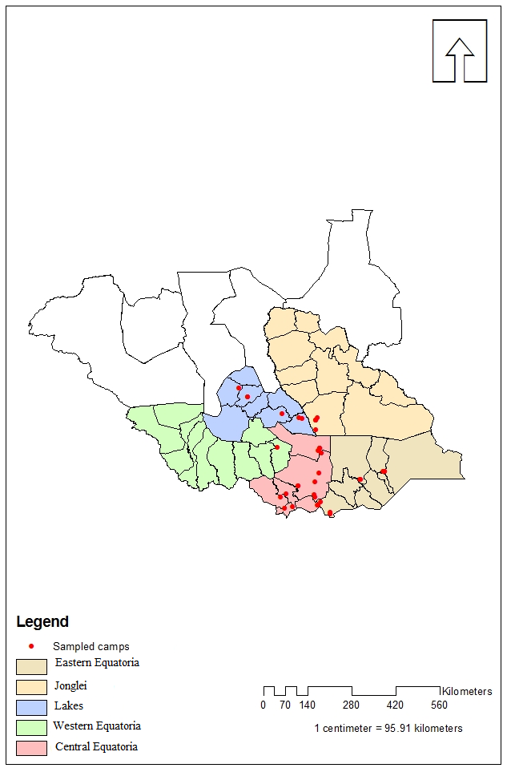
FIGURE 1: Geographical location of the 5 States, Counties and the cattle camps investigated during the cross-sectional survey (September – October 2010).

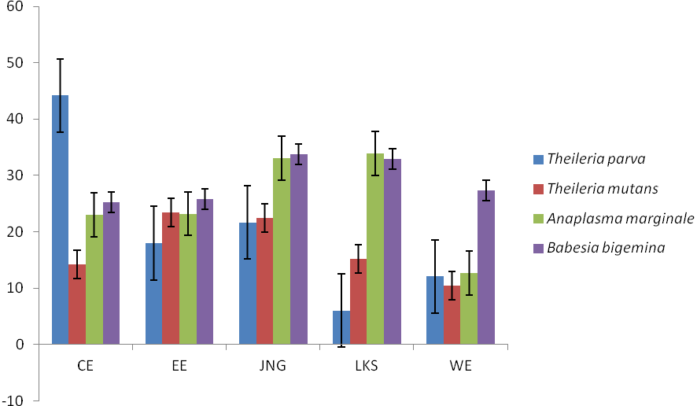
CE, Central Equatoria; EE, Eastern Equatoria State; JNG, Jonglei State; LKS, Lakes State; WE, Western Equatoria State
FIGURE 2: Mean serum antibody sero-prevalence of 805 calves investigated during the cross-sectional survey (September – October 2010).

Y axis: Mean sero-prevalence
X axis: Study States

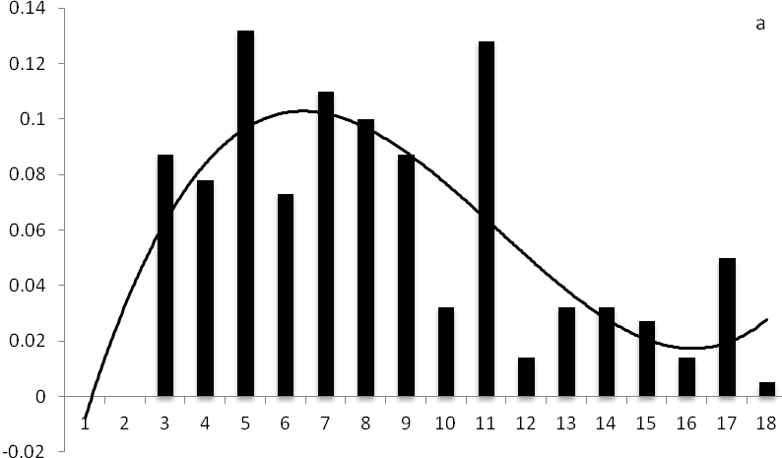

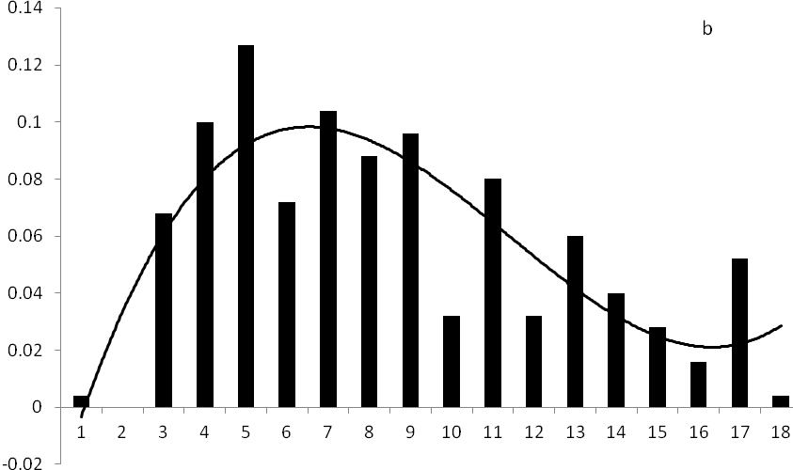

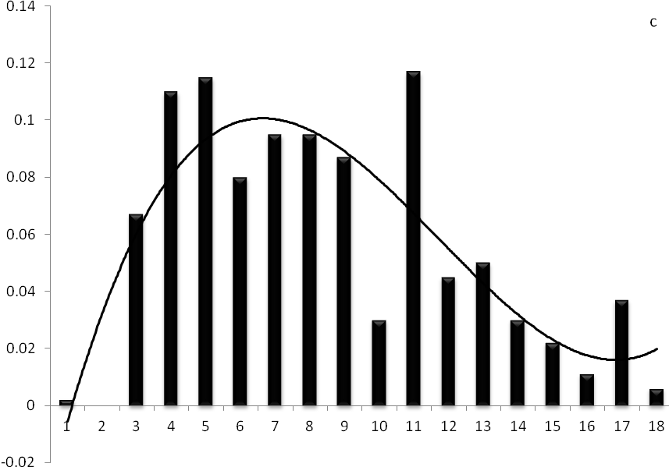

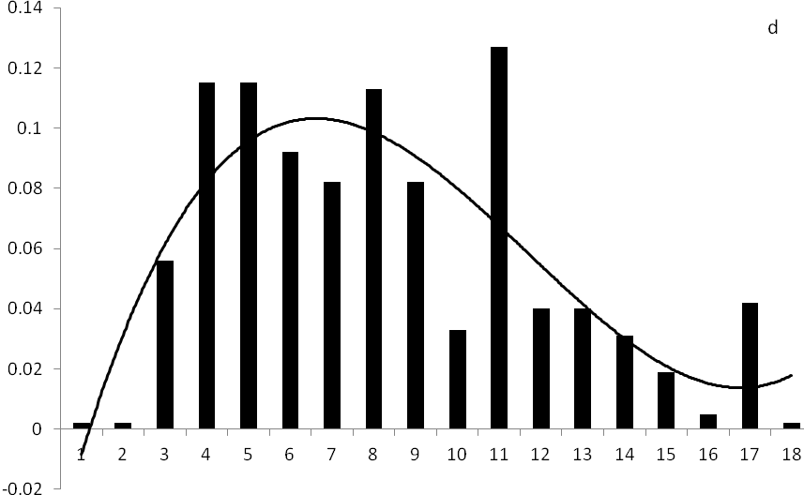

FIGURE 3: Relationship between sero-prevalence for, (a) Theileria parva; (b) Theileria mutans; (c) Anaplasma marginale and (d) Babesia bigemina, and calf age (in months) from five States of South Sudan (September – October 2010).

Figure 3a;
Y axis: Theileria parva sero-prevalence
X axis: Calf age in months

Figure 3b;
Y axis: Theileria mutans sero-prevalence
X axis: Calf age in months

Figure 3c;
Y axis: Anaplasma marginale sero-prevalence
X axis: Calf age in months

Figure 3d;
Y axis: Babesia bigemina sero-prevalence
X axis: Calf age in months
TABLE 1: The distribution of the haemo-parasites detected in five States of South Sudan during a cross-sectional survey (September – October 2010).
State | Parasites seen
State | Theileria parva | Anaplasma marginale | Theileria parva and Anaplasma marginale | Babesia bigemina and  Anaplasma marginale | Trypanosome spp
Central Equatoria | 8 | 1 | 1 | 0 | 0
Eastern Equatoria | 5 | 16 | 1 | 1 | 0
Jonglei | 6 | 9 | 2 | 0 | 1
Lakes | 7 | 12 | 2 | 0 | 0
West Equatoria | 0 | 1 | 0 | 0 | 0

TABLE 2: Variation in the total number of ticks and the individual tick species on calves in the study States, during the cross-sectional survey (September – October 2010).
Ticks | State | Tick counts |  |  | P
Ticks | State | Minimum | Maximum | Median | P
Rhipicephalus appendiculatus | Central Equatoria | 0 | 480 | 0 | ≤ 0.001
 | Eastern Equatoria | 0 | 832 | 0
 | Jonglei | 0 | 240 | 10
 | Lakes | 0 | 240 | 6
 | Total |  | 1.792
Rhipicephalus decoloratus | Central Equatoria | 0 | 384 | 0 | ≤ 0.001
 | Eastern Equatoria | 0 | 112 | 0
 | Jonglei | 0 | 368 | 0
 | Lakes | 0 | 192 | 12
 | Total |  | 1.056
Amblyomma variegatum | Central Equatoria | 0 | 736 | 0 | ≤ 0.001
 | Eastern Equatoria | 0 | 544 | 0
 | Jonglei | 0 | 128 | 9
 | Lakes | 0 | 352 | 0
 | Total |  | 1.760
Rhipicephalus evertsi evertsi | Central Equatoria | 0 | 256 | 0 | ≤ 0.001
 | Eastern Equatoria | 0 | 336 | 0
 | Jonglei | 0 | 32 | 0
 | Lakes | 0 | 256 | 0
 | Total |  | 880
Hyalomma truncatum | Central Equatoria | 0 | 0 | 0 | ≤ 0.001
 | Eastern Equatoria | 0 | 32 | 0
 | Jonglei | 0 | 64 | 11
 | Lakes | 0 | 224 | 0
 | Total |  | 320
Rhipicephalus microplus | Lakes | 0 | 32 | 7

TABLE 3: Prevalence and intensity of Theileria parva infections in non-engorged adult Rhipicephalus appendiculatus collected from calves in five States of South Sudan (September – October 2010).
State | Ticks collected | Number dissected | Number positive for Theileria parva infection |  | Total ticks infected | Total mean intensity‡
 |  |  | N | %
Central Equatoria | 480 | 52 | 13† | 25 | 93 | 7.15
Eastern Equatoria | 832 | 80 | 20 | 25 | 121 | 6.05
Jonglei | 240 | 36 | 10 | 28 | 83 | 8.30
Lakes | 240 | 36 | 9 | 25 | 84 | 9.33
Total | 1,792 | 204 | 52 | 25 | 3381 | 7.33

N, used as means of number.
†, Computed as number positive for Theileria parva infection / number dissected.
‡, Computed as total ticks infected divide by number positive for Theileria parva infection.

TABLE 4: Distribution of Theileria mutans and Babesia bigemina sero-prevalence by States.
State | Parasites
State |  | Theilaria mutans |  |  |  | Babesia bigemina
State | Negative |  | Positive |  | Negative |  |  | Positive
 | N | % | N | % | N |  | % | N | %
Central Equatoria | 144 | 78.30 | 40 | 21.70 | 93 |  | 50.50 | 91 | 49.50
Western Equatoria | 12 | 75.00 | 4 | 25.00 | 8 |  | 50.00 | 8 | 50.00
Eastern Equatoria | 116 | 58.00 | 84 | 42.00 | 117 |  | 58.50 | 83 | 41.50
Jonglei | 125 | 62.50 | 75 | 37.50 | 88 |  | 44.00 | 112 | 56.00
Lakes | 154 | 75.90 | 49 | 24.10 | 74 |  | 36.50 | 129 | 63.50

N, used as means of number.

TABLE 5: Criteria used to characterize endemic stability to bovine theileriosis in the five States studied in South Sudan.
States | Theileria parva sero-prevalence† (%) | Theileria – morbidity‡ (%) | Theileria case fatality risk‡ (%) | Degree of tick challenge§ (%) | Age group | Epidemiologic state
Central Equatoria | 52.20 | 56.00 | 71.01 | 31.61 | All | Unstable
Eastern Equatoria | 24.50 | 35.33 | 65.03 | 32.15 | All | Unstable
Western Equatoria | 25.00 | 42.03 | 59.33 | - | All | Unstable
Jonglei | 29.50 | 30.0 | 75.10 | 14.17 | All | Unstable
Lakes | 5.90 | 36.67 | 57.87 | 22.10 | All | Unstable

†, Sero-prevalence computed as number of calves sero-converted/total number of calves sampled.
‡, Derived from consultative discussions with the State veterinarians.
§, Proportion of calf observations when ticks were present – based on adult tick counts.
TABLE 6: Criteria used to characterise endemic stability to Anaplasma marginale in the five States of South Sudan.
States | Anaplasma marginale sero-prevalence (%) | Anaplasma morbidity (%) | Anaplasma case fatality risk (%) | Degree of tick challenge (%) | Age group | Epidemiologic state
Central Equatoria | 51.60 | 60.00 | 70.00 | 31.61 | All | Unstable
Eastern Equatoria | 51.50 | 66.00 | 70.00 | 32.15 | All | Unstable
Western Equatoria | 18.80 | 40.00 | 82.00 | No data collected | All | Unstable
Jonglei | 62.50 | 48.00 | 70.00 | 14.17 | All | Unstable
Lakes | 67.50 | 71.00 | 70.00 | 22.10 | All | Unstable

TABLE 7: Band sizes (bp) of different PCR DNA from samples examined for p104 allele.
Sample | Bands size (BP) |  | Geneotype similarity
EEM 25 | 220-280 |  | T. parva Muguga
EET 65 | 280-400 |  | T. parva Kiambu 5
EEKN 69 | 280-400 |  | T. parva Kiambu 5
EEM 44 | 150-280 |  | -
EET 54 | 280-400 |  | T. parva Kiambu 5
EEM 29 | 280-400 |  | T. parva Kiambu 5
EEM 31 | 150-280 |  | Uknown
EEM 24 | 220-280 |  | T. parva Muguga
EET 27* | 280-400 |  | T. parva Kiambu 5
EEM 47 | 280-400 |  | T. parva Kiambu 5
EET 39 * | 280-400 |  | T. parva Kiambu 5
EET 63 | 280-400 |  | T. parva Kiambu 5
EET 51 | 150-280 |  | -
EET 30* | 280-400 |  | T. parva Kiambu 5
EET 57 | 150-280 |  | -
JGB 88 | 220-280 |  | T. parva Muguga
LKA 29 | 280-400 |  | T. parva Kiambu 5
LKA 22 | 280-400 |  | T. parva Kiambu 5
LKA 21 | 280-400 |  | T. parva Kiambu 5
+F | 220-280 |  | T. parva Muguga
CEL 3 | 220-280 |  | T. parva Muguga
JGB 97 | 220-280 |  | T. parva Muguga
JGB 30 | 220-280 |  | T. parva Muguga
JGB 45 | 220-280 |  | T. parva Muguga
JGB 41 | 220-280 |  | T. parva Muguga
JGB 92 | 280-400 |  | T. parva Kiambu 5
CEL 48 | 220-280 |  | T. parva Muguga
CET 51 | 220-280 |  | T. parva Muguga
CET 46 | 280-400 |  | T. parva Kiambu 5
CET 48 | 220-280 |  | T. parva Muguga
CEJ 17 | 220-280 |  | T. parva Muguga
CEJ 9 | 220-280 |  | T. parva Muguga
CEJ 21 | 280-400 |  | T. parva Kiambu 5
CET 53 | 280-400 |  | T. parva Kiambu 5
CET 35 | 280-400 |  | T. parva Kiambu 5
CET 44 | 280-400 |  | T. parva Kiambu 5
LEK 29 | 280-400 |  | T. parva Kiambu 5
CEK 40 | 280-400 |  | T. parva Kiambu 5
CET 54 | 280-400 |  | T. parva Kiambu 5
CEJ 32 | 280-400 |  | T. parva Kiambu 5
CET 22  CET 45 | 220-280  220-280 |  | T. parva Muguga  T. parva Muguga

